In general:

* Please change the font on the titles of every page (at the top) to the same font style as the rest of the writing on the page. But please put it in bold. I don’t want the italic/Asian looking font.
* Is it possible to make the pages black background with white font? If so, I would like the About, Keynote Speaker and Educational Consultant pages to have a black background.
* Make the YoungLeaders.World logo on the left a little smaller

**Home Page:** Please make sure that all of the ‘typed out’ words stay on the page as the other ones come up.

-I would like the words to say (in this order)

“Youth Engagement”

“Global Educator.”

“Humanitarian.”

“Portfolio” tab should be lower on the page and should say – “contact”

Upon arrival to the contact page, it should read:

“Contact Carla about speaking at your event, school or organization.”

I would like this to lead to a contact page where people can fill in their info and it will get emailed to [Carla@youngleaders.world](mailto:Carla@youngleaders.world)

**About Page:** Please move “Awards and Features” from being its own page to a tab on the ABOUT page and remove it from the tabs on the left. It should replace the “contact” tab.

Please add the photo of me blue jacket called Carla Head Shot Stage to the “about “page landing photo.

**Keynote Speaker (I would like this page to look like the “Humanitarian Page” ) with the pictures that you can scroll over.**

Please move the video to the keynote speaker page and move the photo of me speaking to the bottom of that page.

Crop that photo so that you do not see the shoes of the person on the big screen behind me.

I would like to speaker picture and description to stay at the top. Then 3 pictures with titles across the bottom. These pictures should have the title that stays on even when you are not scrolling over. The scroll over text should reveal an explaination of what I talk about.

Title: Leadership. Setting Vision and Direction



Scroll over to read:

Carla uses concrete examples of personal leadership all-stars who have used the power of vision setting to bring themselves and their communities to reach their fullest potential.

Title: Engaging Next Gen



Scroll over to read:

Carla has worked in Africa, Asia or North America with educators and young people to tackle the same challenge; keeping the next generation engaged in learning and in life.

As the Co-Founder of YoungLeaders.World, Carla has provided leadership training to over 10,000 young people in personal growth and collective good over the past 3 years.

As an educator her experience ranges from curriculum redesigns related to 21st century learning, creating lipped classrooms in self-directed schools, to peace education in one-room schools in Sierra Leone.

Title: Leadership with Global Insights

(please put the photo of me with my head covered here)

Scroll over should read:

Over the 18 years Carla has been involved in humanitarian work in Sierra Leone, China, India, Uganda, Mexico, Costa Rica and Laos. Her goal is to learn from and work with local change makers to help raise people out of poverty. These partnerships tackle the root causes of poverty by focusing on education, access to water, and rights for women. Carla will weave together lessons with incredible stories of growth and triumph and help people understand how they too can make a difference in their communities.

On the **Global Work Page:**

I would like the photos to be smaller with titles that stay on even when not scrolling

Engaging and Inspiring Youth

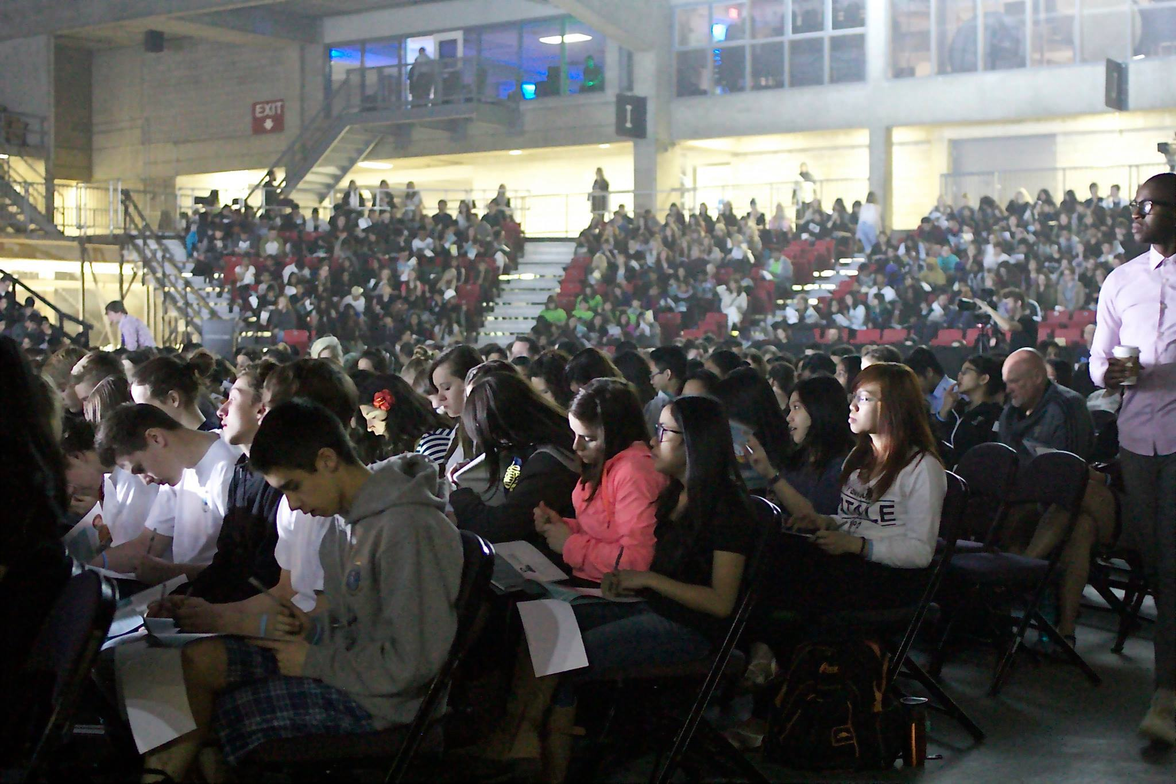

Replace the Sierra Leone photo with Peace Hut photo

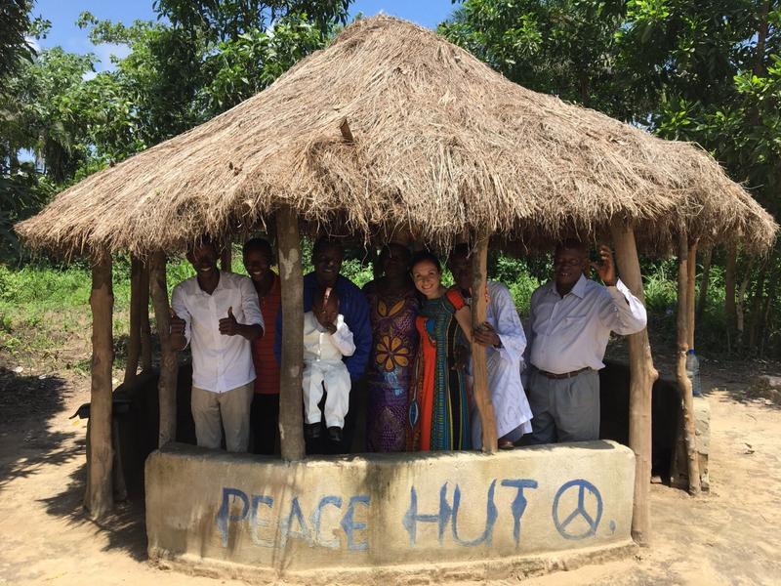

Replace my head covered shot with the women in India shot

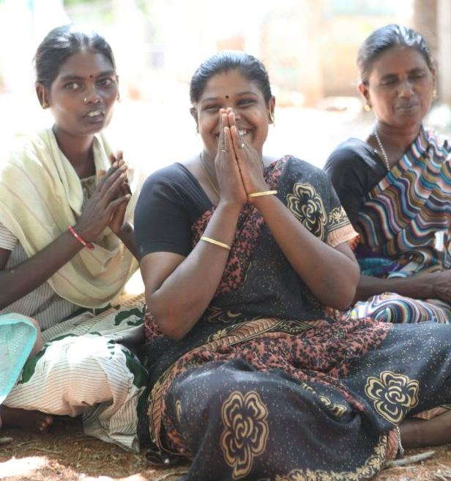

Replace the local involvement with the crowd shot

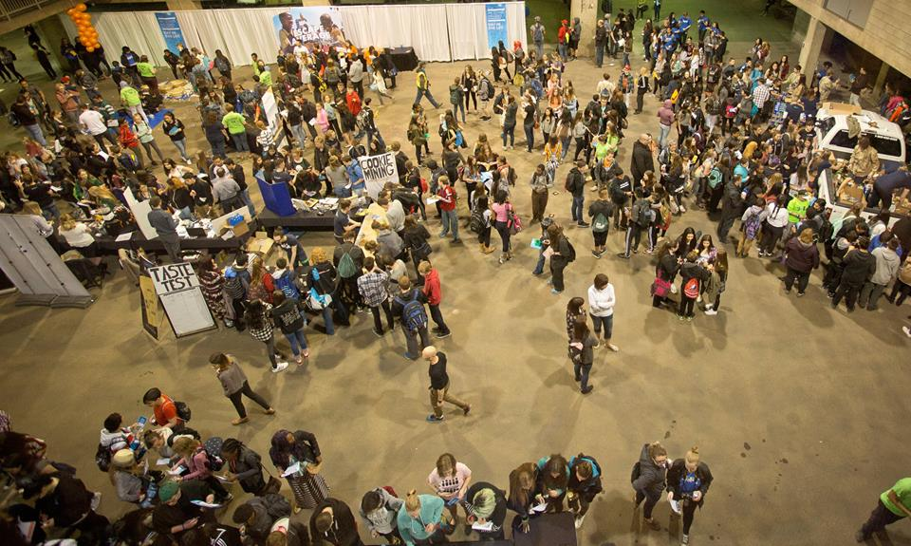

**Courses Page:**

The India PDF is ready.

Somehow I would like a link that they can click on to contact me about the course.

“Contact For More Information”

Where they can fill in:

Name:

Age:

City/Country of Residence:

Course Interested in:

This email should come to [Carla@youngleaders.world](mailto:Carla@youngleader.world)